My PC Vuln

Vulnerability Report

Thursday, June 10, 2021



modifications history
Version | Date | Author | Description
1.0 | 06/10/2021 | Gopi nandan reddy 19bcn7056 | Initial Version

Table of Contents

1. General Information 4
1.1 Scope 4
1.2 Organisation 4
2. Executive Summary 5
3. Technical Details 6
3.1 title 6
4. Vulnerabilities summary 8

General Information

Scope
VIT-AP has mandated us to perform security tests on the following scope:
- Testing Personal Computer Vulnerabilities using WES-NG

Organisation
The testing activities were performed between 06/08/2021 and 06/11/2021.

Executive Summary

Vulnerabilities summary
Following vulnerabilities have been discovered:

Risk | ID | Vulnerability | Affected Scope
Medium | VULN-001 | FINDING AND PATCHING Vuln's USING WES-NG | Affected product: net framework 4.8 on windows 10 version 20H2  ISSUSING CNA  Impact will be: DOS - DENIAL OF SERVICE

Technical Details

FINDING AND PATCHING Vuln's USING WES-NG
CVSS Severity | Medium |  | CVSSv3 Score |  | 6.3
CVSSv3 criterias | Attack Vector : | Network | Scope : | Unchanged
CVSSv3 criterias | Attack Complexity : | Low | Confidentiality : | Low
CVSSv3 criterias | Required Privileges : | Low | Integrity : | Low
CVSSv3 criterias | User Interaction : | None | Availability : | Low
Affected scope | Affected product: net framework 4.8 on windows 10 version 20H2  ISSUSING CNA  Impact will be: DOS - DENIAL OF SERVICE
Description | WES-NG is a tool based on the output of Windows' systeminfo utility which provides the list of vulnerabilities the OS is vulnerable to, including any exploits for these vulnerabilities. Every Windows OS between Windows XP and Windows 10, including their Windows Server counterparts, is supported.
Observation | Let's see the detected vulnerabilities.  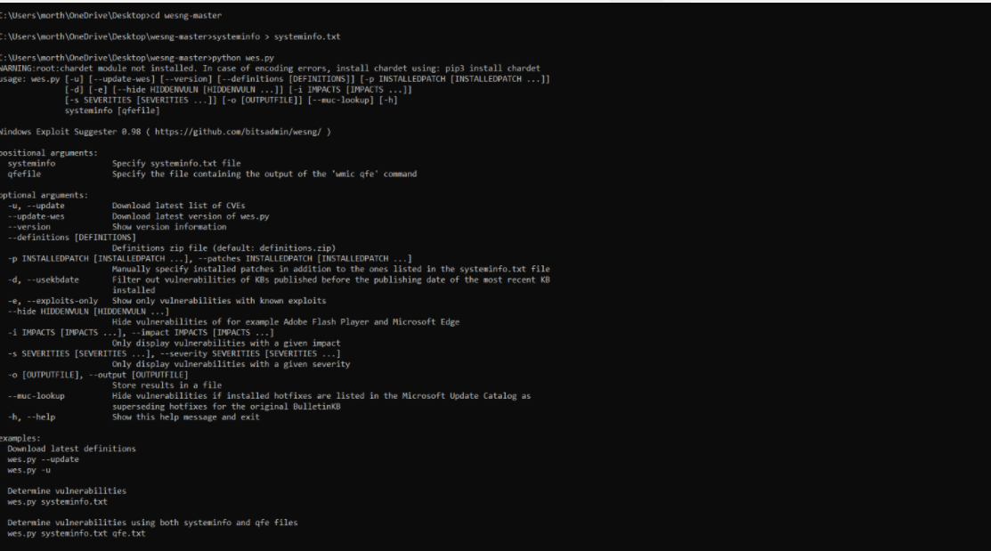

Test details

The vulnerability detected is not patchable as the exact version of windows is not detected.

https://www.catalog.update.microsoft.com/Search.aspx?q=KB4601050

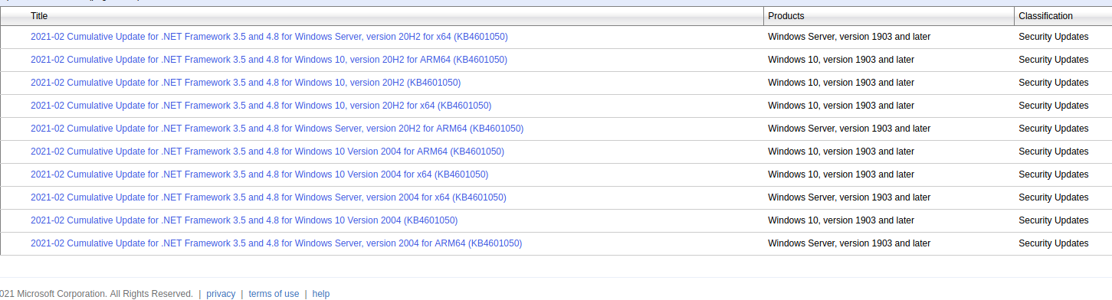

Remediation | Windows just need to release the patch for all the versions of their systems, so as of now it still remains un-patchable but as the risk is low its acceptable as of now.  Impact will be denial of service.  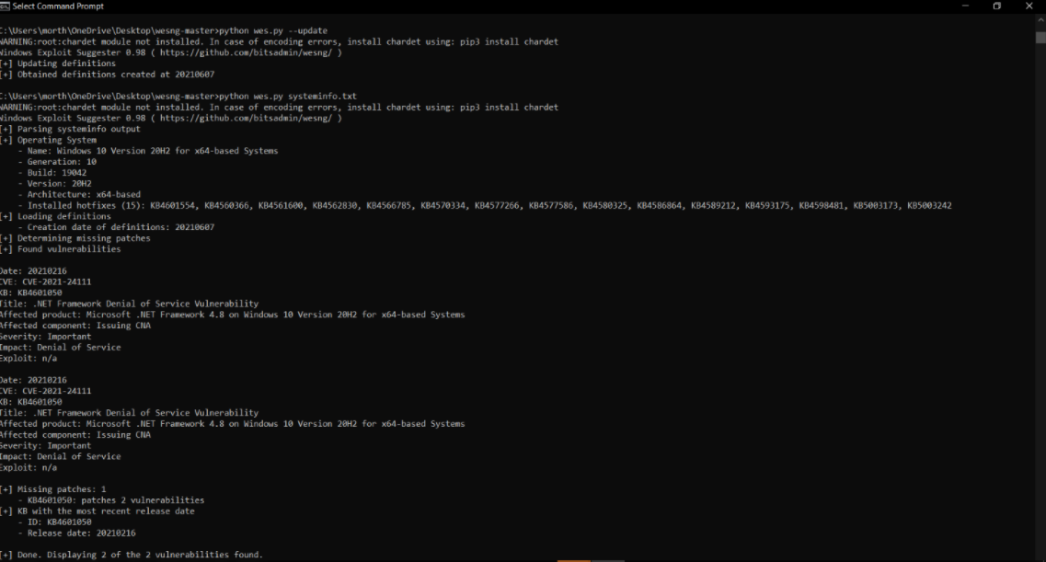
References | https://github.com/bitsadmin/wesng

